**CS1081 TEDd Talk Plagirism Declaration**

**"I have read and I understand the plagiarism provisions in the General Regulations of the University Calendar for the current year, found at**[**http://www.tcd.ie/calendar**](http://www.tcd.ie/calendar/)**.**

**I have also completed the Online Tutorial on avoiding plagiarism ‘Ready Steady Write’, located at**[**http://tcd-ie.libguides.com/plagiarism/ready-steady-write**](http://tcd-ie.libguides.com/plagiarism/ready-steady-write)**."**

**Signed**

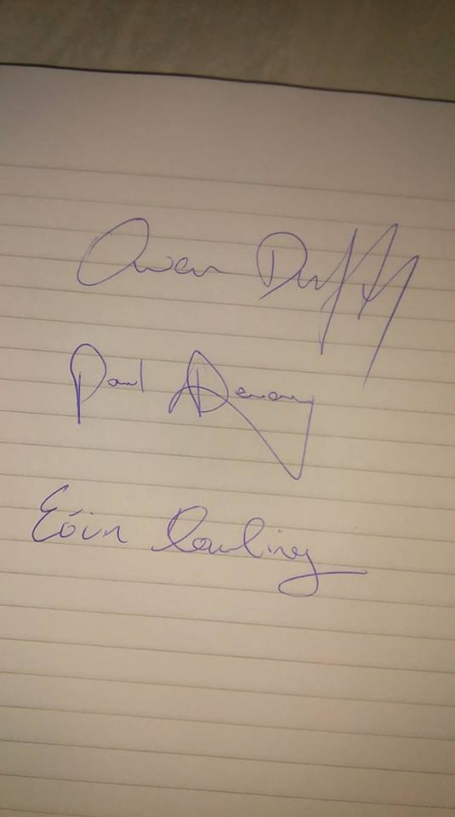

**________________**

Eoin Dowling